Week 14
Problem Statement:
You are transporting some boxes through a tunnel, where each box is a parallelepiped,
and is characterized by its length, width and height.
The height of the tunnel 41 feet and the width can be assumed to be infinite. A box can be
carried through the tunnel only if its height is strictly less than the tunnel's height. Find the
volume of each box that can be successfully transported to the other end of the tunnel.
Note: Boxes cannot be rotated.
Input Format
The first line contains a single integer n, denoting the number of boxes.
n lines follow with three integers on each separated by single spaces - lengthi, widthi and
heighti which are length, width and height in feet of the i-th box.
Constraints
1 ≤ n ≤ 100
1 ≤ lengthi, widthi, heighti ≤ 100
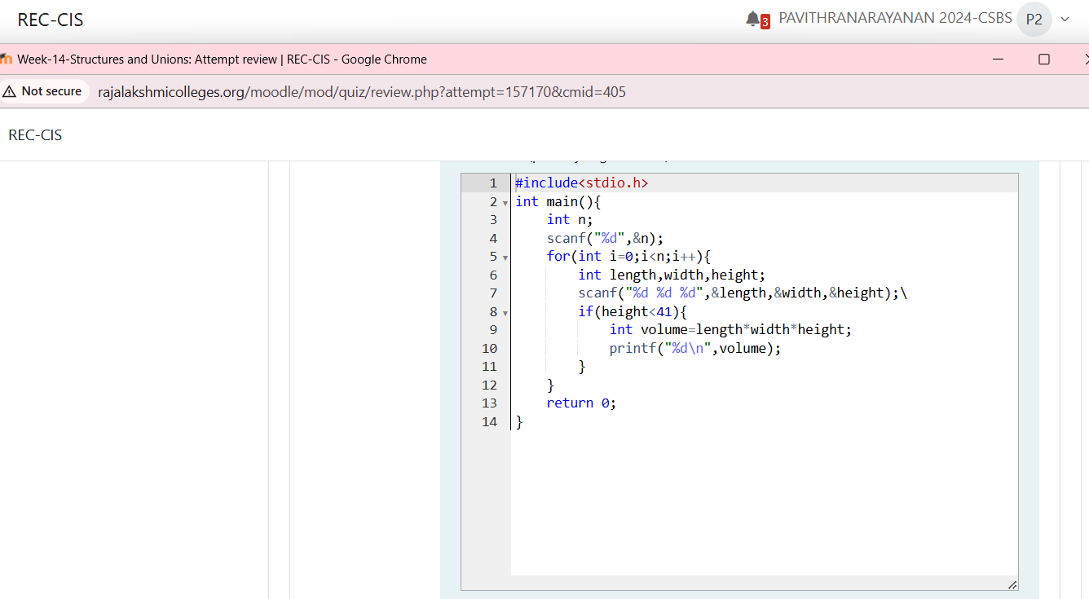
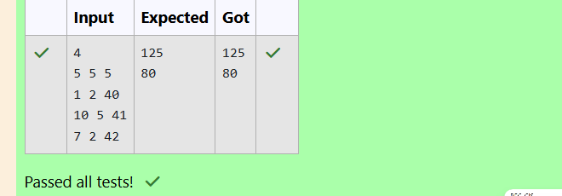
Problem Statement:
You are given n triangles, specifically, their sides ai, bi and ci. Print them in the same style
but sorted by their areas from the smallest one to the largest one. It is guaranteed that all
the areas are different.
The best way to calculate a volume of the triangle with sides a, b and c is Heron's formula:
S =  p * (p – a) * (p - b) * (p – c) where p = (a + b + c) / 2.
Input Format
First line of each test file contains single integer n. n lines follow with ai, bi and ci on each
separated by single spaces.
Constraints
1 ≤ n ≤ 100
1 ≤ ai, bi, ci ≤ 70
ai + bi > ci, ai + ci > bi and bi + ci > ai
